

MANGU 2025 KCSE PREDICTION
CONFIDENTIAL EXAM
231/3
BIOLOGY
PAPER 3 (PRACTICAL)
TIME: 1¾ HOURS

NAME……………………………………………………………………………………….
SCHOOL……………………………………………… SIGN………………………..
INDEX NO……………………………………………. ADM NO……………………

(Kenya Certificate of Secondary Education)

INSTRUCTIONS TO CANDIDATES:
- Write your name and admission number in the spaces provided.
- Sign and write date of examination in the spaces provided above
- Answer all the questions in section in the spaces provided after each question only
- You are required to spend the first 15 minutes of the 1 ¾ hours allowed for this paper, reading the whole paper carefully before starting to do this paper.

FOR EXAMINER’S USE ONLY:
QUESTIONS | MAXIMUM SCORE | CANDIDATE’S SCORE
1 | 16
2 | 11
3 | 13
TOTAL | 40

1. You are provided with two test-tubes. Label them as A and B. You are required to prepare the contents of test tube A and B as follows. To test tube A, add 2 cm³ of solution R provided and test using the provided reagent. To test tube B, add 2 cm³ of solution T provided and test using the provided reagent. (5 Marks)
(a)
Test tube | Procedure | Observation | Conclusion
A
B

(b) To the provided visking tubing tie one end with the provided string and add solution R. Tie the remaining end and immerse it in a solution of iodine solution in a beaker (50ml). After 5-10 minutes remove it from the beaker and observe.
(i) What was your observation of the contents of the visking tubing at the end of experiment?
(1 Mark)
…………………………………………………………………………………………………………
(ii) Account for your results in (i) above. (4 Marks)
…………………………………………………………………………………………………………
…………………………………………………………………………………………………………
…………………………………………………………………………………………………………
…………………………………………………………………………………………………………
…………………………………………………………………………………………………………
…………………………………………………………………………………………………………
(c) Explain two roles of physiological process under investigation in (c) above in living organisms.
(2 Marks)
…………………………………………………………………………………………………………
…………………………………………………………………………………………………………
…………………………………………………………………………………………………………
…………………………………………………………………………………………………………

d) You are provided with specimen Q. Cut a longitudinal section specimen of specimen Q to make two parts. Add one drop of iodine solution on the surface of one of the exposed surfaces.
(i) State the observation (1 Mark)
…………………………………………………………………………………………………………

(ii) Explain the observations made in d(i) above. (3 Marks)
…………………………………………………………………………………………………………
…………………………………………………………………………………………………………
…………………………………………………………………………………………………………
…………………………………………………………………………………………………………

2. The photographs below shows different types of flowers. Photograph V is a flower obtained from a Hibiscus plant while photograph W is a flower obtained from Bougainvillea plant.
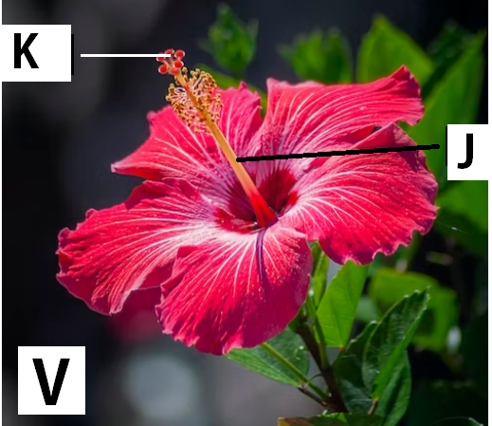

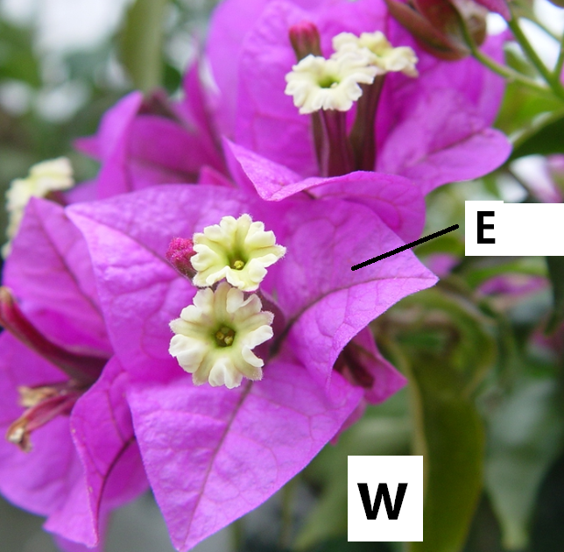

(a) On the photograph, name the part labelled J and K (2 Mark)
(b) (i) Name the agent of pollination for the flowers in the photograph (1 Mark)
…………………………………………………………………………………………………………

(ii) State three observations on the photographs that support the answer you have given in (b)(i) above (3 Marks)
…………………………………………………………………………………………………………
…………………………………………………………………………………………………………
…………………………………………………………………………………………………………
…………………………………………………………………………………………………………
…………………………………………………………………………………………………………
…………………………………………………………………………………………………………
…………………………………………………………………………………………………………
…………………………………………………………………………………………………………

(c) (i) Name the class of plant from which the photograph V was taken (1 Mark)
…………………………………………………………………………………………………………

(ii) Using observable features on the photograph, give the three reasons for your answer in c (i) above (3 Marks)
…………………………………………………………………………………………………………
…………………………………………………………………………………………………………
…………………………………………………………………………………………………………
…………………………………………………………………………………………………………
(iii) Name part labelled E on the photograph W (1 Marks)
…………………………………………………………………………………………………………

3. The photographs below were taken from specimens obtained from mammalian skeleton. Evaluate them and use them for answering questions.
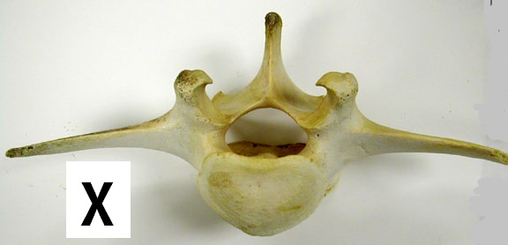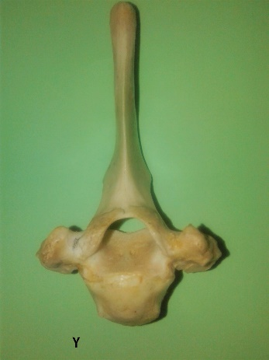
Y
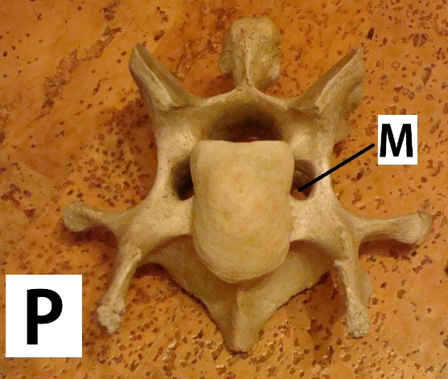
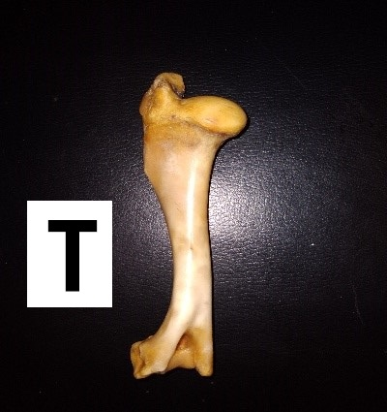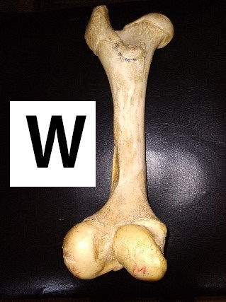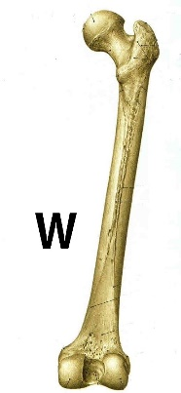
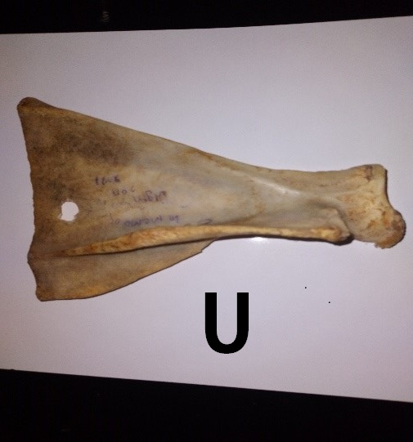
(a) Identify the bone labelled X, Y, and T (3 Marks)
X………………………………………………….
Y…………………………………………………
T …………………………………………………

(b) State the function of part labelled M in bone P (1 Mark)
…………………………………………………………………………………………………………
(c) (i)Name the type of joint formed in the proximal end of bone T (1 Mark)
…………………………………………………………………………………………………………
(ii) State two characteristics of the joint named in c(i) above (2 Marks)
…………………………………………………………………………………………………………
…………………………………………………………………………………………………………

(iii) On the image U, label two parts. (2 Marks)

(d) Discuss various adaptations of bone W to its functions (4 Marks)
…………………………………………………………………………………………………………
…………………………………………………………………………………………………………
…………………………………………………………………………………………………………
…………………………………………………………………………………………………………
…………………………………………………………………………………………………………
…………………………………………………………………………………………………………
…………………………………………………………………………………………………………

